**solution report**

As part of a task to detect soil erosion, a dataset was provided that included a Sentinel2 tile and erosion masks for that tile. The task was to train a model to detect erosion.

To solve this task, Python libraries such as TensorFlow, Keras, NumPy, Pandas, and Matplotlib were used. For convenience, a Jupyter notebook was used for development.

The approach described in the article "Preparing Aerial Imagery for Crop Classification" was used to prepare the data. Specifically, the images were normalized and resized, data augmentation was applied, and masks were used to create a pixel mask indicating the presence of erosion in each pixel. The following information was used to transform the images:

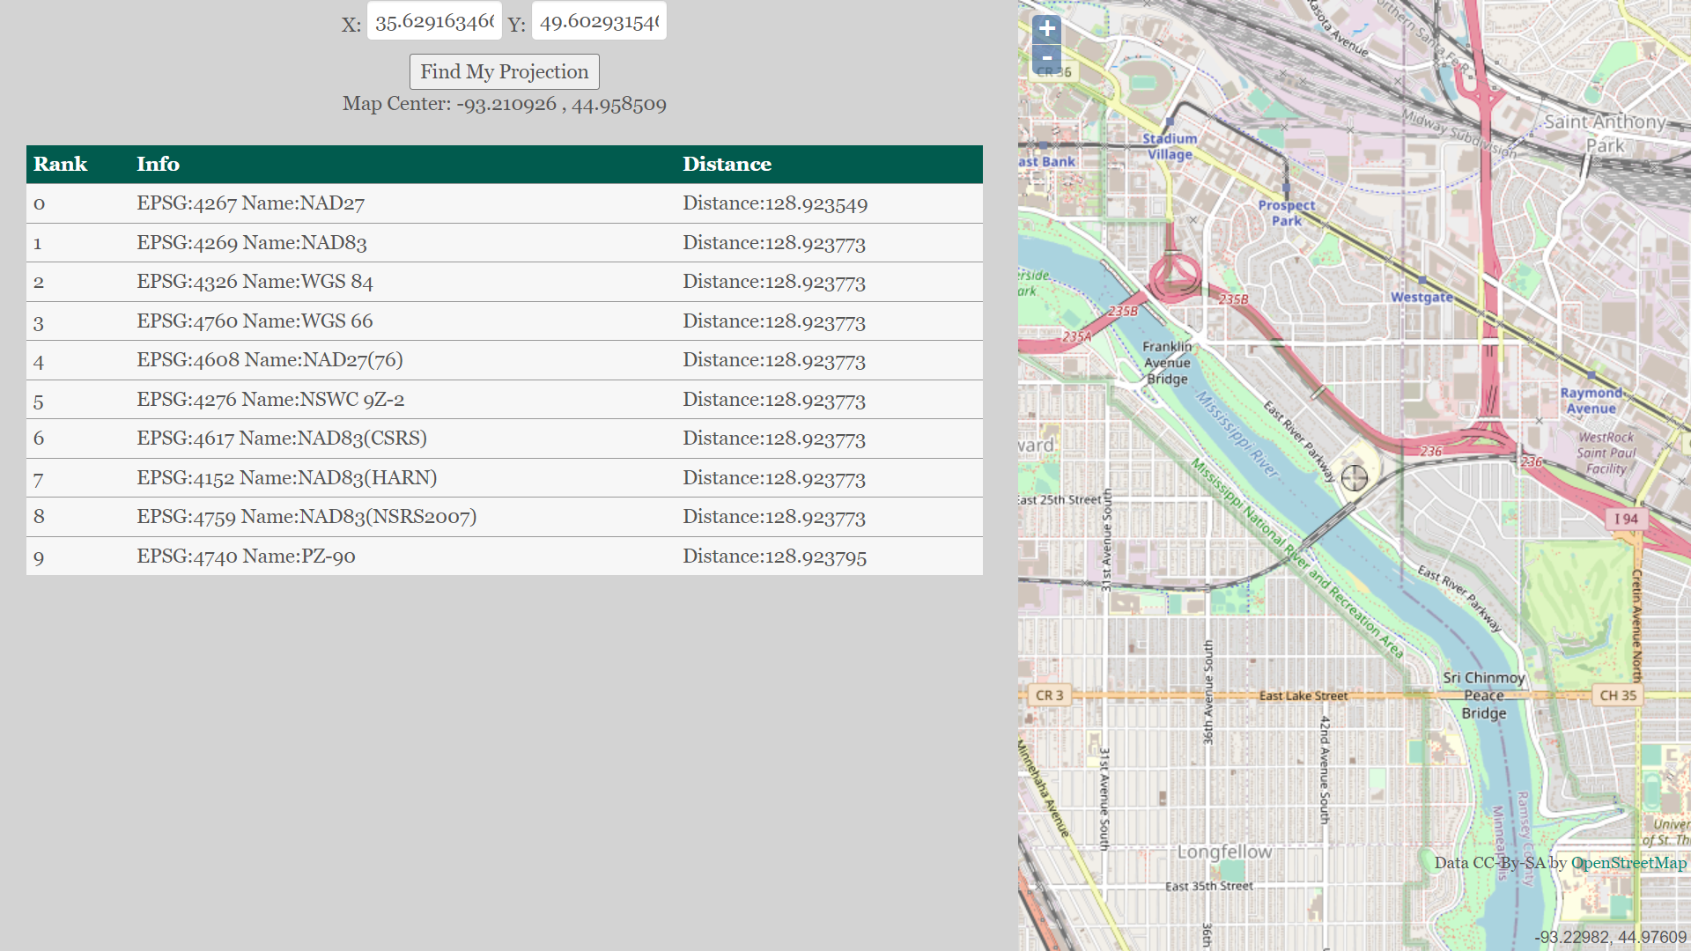

After preparing the data, a model based on a neural network was created and trained. The Unet architecture was used, which proved to be quite effective for solving this task.

After training the model, its performance was evaluated on test data.

Materials containing ideas and information related to solving this problem are:

"Deep Learning Approaches for Semantic Segmentation of Earth Observation Data: A Review" by H. Zhao et al. This paper reviews deep learning approaches for semantic segmentation of earth observation data, including satellite images. It includes a discussion on how deep learning can be used to detect erosion.

"Monitoring Soil Erosion with Unmanned Aerial Vehicles (UAVs): A Review" by S. P. Aryal et al. This article reviews the use of unmanned aerial vehicles (UAVs) to monitor soil erosion. It discusses how UAVs can capture high-resolution images that can be used for erosion detection.

"Assessment of soil erosion using machine learning techniques" by S. M. Pudaruth et al. This article discusses how machine learning techniques can be used to assess soil erosion. It includes a discussion on various machine learning algorithms that can be used for this purpose.

"Agricultural land cover classification for soil erosion prediction using satellite imagery and machine learning" by A. Singh et al. This paper discusses how machine learning can be used for agricultural land cover classification, which can then be used to predict soil erosion.

"Image-based soil erosion detection using convolutional neural networks" by S. S. Islam et al. This article discusses how convolutional neural networks (CNNs) can be used for image-based soil erosion detection. It includes a detailed description of the CNN architecture used for this purpose.

"Soil Erosion Detection Based on Deep Learning with Multi-Scale Features" by Y. Hu et al. This paper discusses how deep learning can be used for soil erosion detection. It includes a detailed description of the deep learning architecture used, which combines multi-scale features to improve erosion detection.

"Soil erosion detection and classification using machine learning techniques" by G. V. Bhosale et al. This article discusses how machine learning techniques can be used for soil erosion detection and classification. It includes a comparison of various machine learning algorithms for this purpose.

"A machine learning approach for soil erosion prediction using remote sensing data" by L. M. T. Costa et al. This paper discusses how machine learning can be used for soil erosion prediction using remote sensing data. It includes a discussion on various machine learning algorithms and their performance for this purpose.